Introduction

Terminology:
A JIRA 'issue' is created for each sample. All of the samples for all of the sequencing projects are in the 'Sample Tracking' project. In JIRA issues are identified by the abbreviated project name followed by a number; all samples in JIRA Sample Tracking have IDs in the form 'ST-9999'.
The state of the sample is tracked via the 'status' of the ticket. The status is linked to the workflow; the sample progresses through the workflow by 'transitioning' (moving) between 'workflow steps'; being assigned the associated status at each step.
Activities, such as sequencing, PCR and closure, are represented by 'sub-tasks'. Sub-tasks have their own statuses and workflows but follow a similar process of transitioning from one step to another.

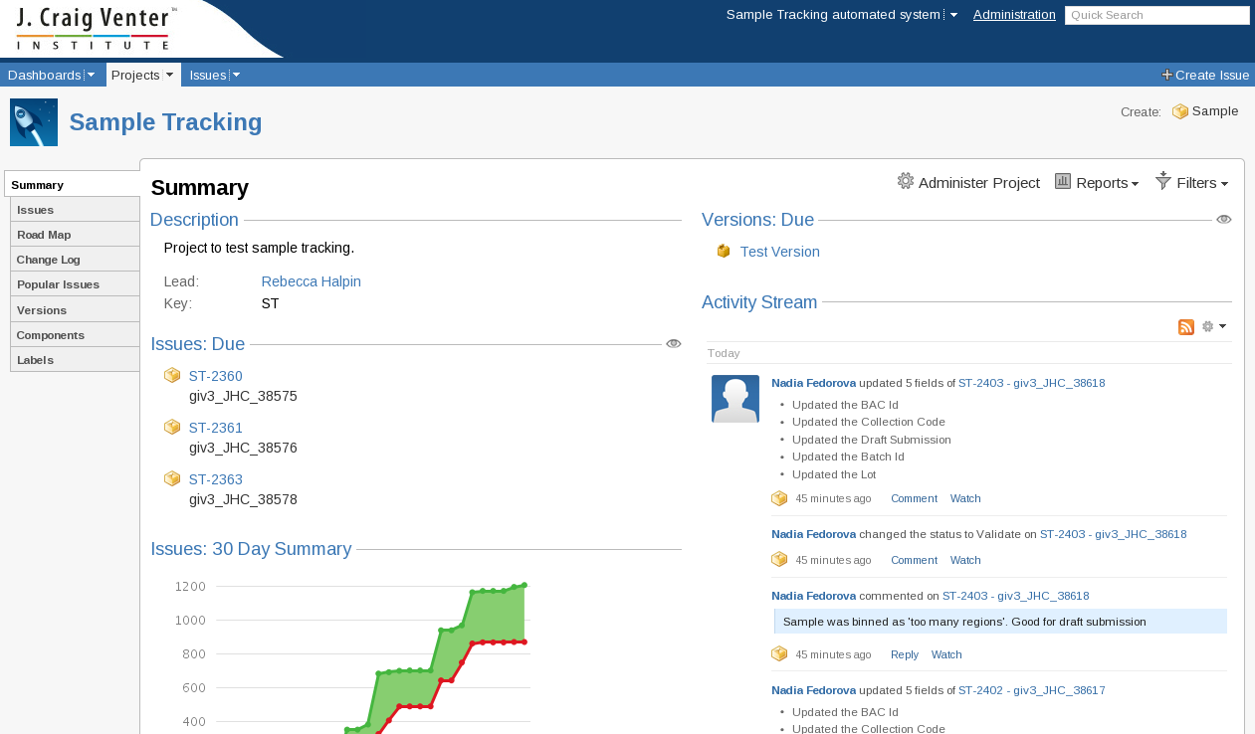
Illustration 1: The Sample Tracking Project Page

Searches / Filters

Starting a new Search
To search for a particular sample/sub-task or group of samples/sub-tasks the 'Issue Navigator' is used. This is accessed by clicking on 'Issues' in the top menu bar (See Illustration 2: The left side of the top menu bar).
Illustration 2: The left side of the top menu bar
Clicking 'Issues' will open the Issue Navigator page. The search is controlled from the area at the left of the screen, the 'Search Side-bar' (see Illustration 3: The Search Side-bar).
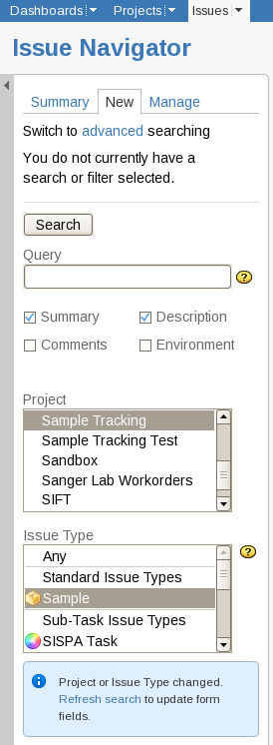
Illustration 3: The Search Side-bar
1
3
4
2
2

Note:
If the search side-bar becomes minimized only a gray bar will be visible at the side of the screen. If this happens click on the arrow pointing to the right near the top of the bar to return the side-bar to its normal size (Illustration 4: A minimized Search Side-bar).
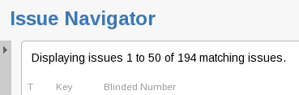
Illustration 4: A minimized Search Side-bar

Using the search side-bar (in Illustration 3); selecting 'New(1)' will clear any existing criteria and start an empty search. With no criteria the new search would select all of the issues in JIRA. Criteria can be added to specify which issues should be included in the selection. These are controlled through the forms in the search side-bar. The 'Project' (2) and 'Issue Type' (2) are special as they control not only what is selected but also which fields are included in the search side-bar and the results table.
If 'Project' and/or 'Issue Type' have been changed a dialog appears below the 'Issue Type' (3). Clicking on the link will update the available criteria in the search side-bar to include fields that are unique to the Project or Issue Type. These extra fields appear at the bottom of the form in the search side-bar.
With just the 'Project' (2) and 'Issue Type' (2) specified (shown in Illustration 3), all samples in Sample Tracking would be selected.
Once all the criteria have been set the list of selected issues can be updated by clicking the 'Search' button (The 'Search' button appears at both the top and the bottom of the search side-bar)
Clicking 'Search' (4) submits the search and, up to the first 50, matching issues are displayed. The table of issues contains a number of columns of data on each issue. The columns shown are determined by a combination of the issue types selected and the user's settings. Configuring which columns appear is done from the 'Manage' tab and is covered later in the section titled 'Columns in Issue Navigator'.
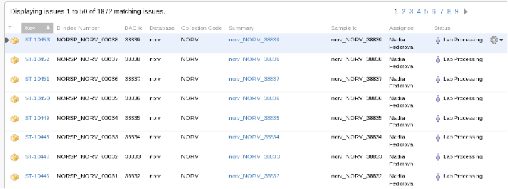
Illustration 5: The result of a search
WARNING
In the search side-bar's 'Issue Attributes' section 'Unresolved' appears as a value for both the 'Status' and the 'Resolutions' fields (See Illustration 6: Use status for samples that are in the 'Unresolved' state).
Unresolved Status
This is interpreted based on JCVI's use of the term unresolved. A sample is 'Unresolved' if it will not be submitted. No further work is done on a sample that has an 'Unresolved' 'Status'.
Searching for 'Status = Unresolved' returns all of the samples that have finished at the 'Unresolved Step' in the workflow.
Unresolved Resolution
This is JIRAs definition of unresolved: Issues are 'Unresolved' when the field 'Resolutions' is empty. The field being empty is interpreted by JIRA as indicating that an issue requires further work / has not been closed.
Searching for 'Resolutions = Unresolved' returns all of the samples that are not finished (They do not have a status of Unresolved, Deprecated or Sample Published)
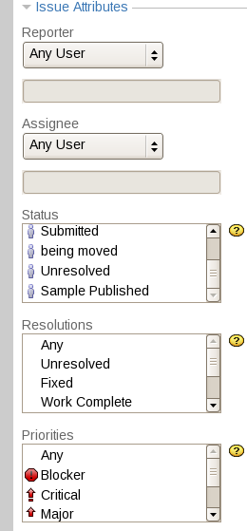
Illustration 6: Use status for samples that are in the 'Unresolved' state

This number depends on the user's settings

